To appear in London Bridges, 2006

Sculpture Puzzles

George W. Hart
Dept. Computer Science
Stony Brook University
Stony Brook, NY, 11794, USA
http://www.georgehart.com
E-mail: george@georgehart.com

Abstract

A series of novel sculpture-puzzles is illustrated, with mathematical explanation. Each consists of a set of identical parts that snap together into a symmetric form. The parts are flat, so they can be cut out or stamped from sheet materials such as wood, metal, plastic, or cardboard. High accuracy is required for the parts to mate properly, so computer-controlled fabrication technologies are useful. The examples shown were made by laser-cutting, by solid freeform fabrication techniques, or by scissors and paper. Their intricate geometric forms make for challenging assembly puzzles and attractive artworks. A template and instructions show how to make one from paper.

1. Introduction

Twelve copies of the shape outlined in Figure 1a can be cut out and assembled to form the construction shown as a virtual model in Figure 1b. If made of a thin, slightly flexible sheet material, the parts would snap together and directly hold each other in position without any glue or connectors. Although far from regular, the flat shape is directly related to the underlying regular pentagon and the assemblage is directly related to an implicit underlying dodecahedron. The parts meet each other in threes at the dodecahedron vertices and in twos at the midpoints of the dodecahedron edges.

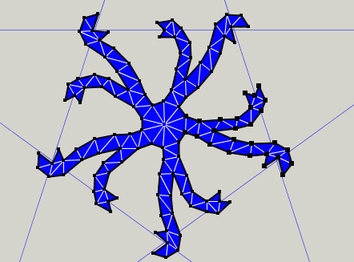 | 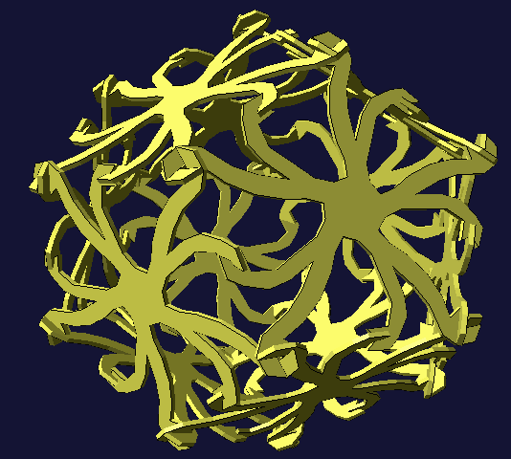
Figure 1a: Flat piece layout, based on pentagon. | Figure 1b: Assemblage of twelve pieces.

To understand how the parts are rigidly locked together, it is important to notice that the tips of the arms in Figure 1a point alternately clockwise and counterclockwise. If all arms faced clockwise or if all faced counterclockwise, then the parts could still be positioned together but any part could “unscrew” from the assemblage of Figure 1b, so the structure would not hold together. With half the mating surfaces facing each direction, they are locked. But there must be some flex in the material to insert the pieces.
The designer has freedom in choosing how the arms are shaped in Figure 1a, as long as the tips of each arm end up at the appropriate location facing the chosen direction. With a symmetric result in mind, the twelve parts were chosen to be identical, each with 5-fold symmetry about their centers. This is not essential to the mathematical connectivity; it simply leads to what I consider an attractive sculptural form. There are only two types of arms and they exactly repeat, which gives a visual coherence to the final form. The use of non-identical parts with different types of arms could add a permutational aspect to future puzzle designs.

The construction of Figure 1 is pedagogical, to show the key ideas of the puzzles illustrated below. It is not intended as a puzzle itself, because it would be overly simple to solve, assuming one can visualize a dodecahedron. But variations lead to more interesting puzzle designs. To generalize the idea, notice that the tips of the arms meet at 3-fold or 2-fold rotational axes of the dodecahedron. In general, this paper considers flat shapes that lie in the face planes of a symmetric polyhedron with arms that extend to two different types of points where symmetry axes pass through the planes. One type of arm has a mating surface facing clockwise and the other type faces counterclockwise. This is a highly restrictive set of design rules, but has enough freedom to allow the exploration of a wide range of interesting sculpture puzzles. Some of these I have physically made and assembled, as illustrated herein.

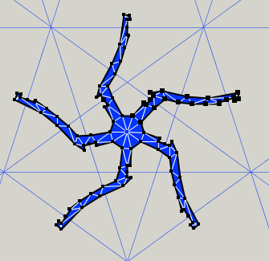 | 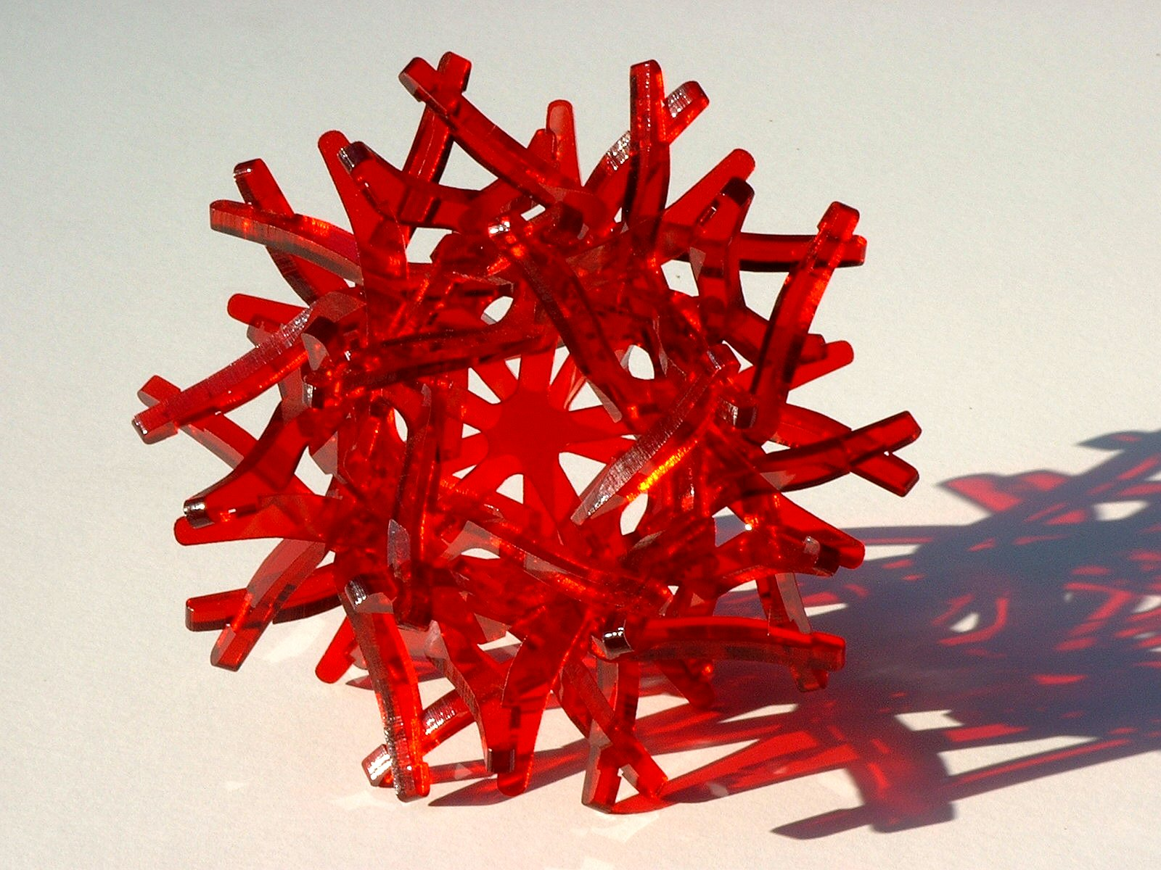
Figure 2a: Part based on dodecahedron. | Figure 2b: Construction in transparent acrylic.
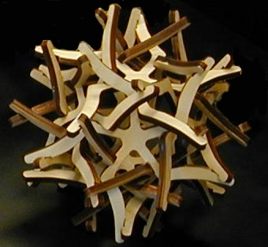 | 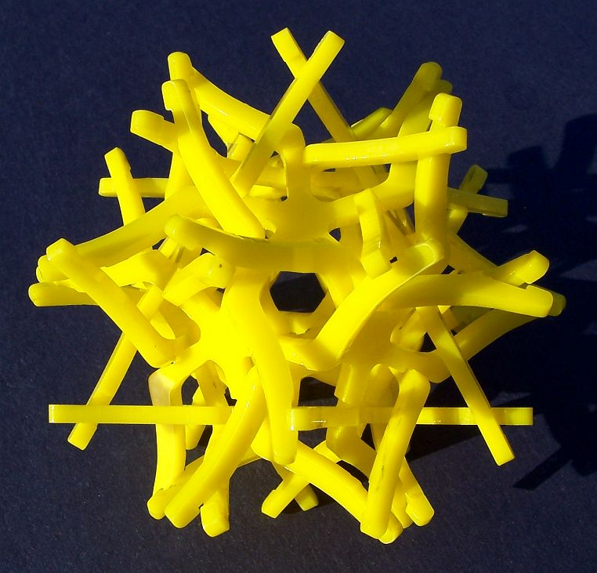
Figure 2c: Construction in wood. | Figure 2d: Construction in acrylic.
2. Sculpture Puzzle Examples

For several years, I have been designing puzzles that are variations on the ideas behind Figure 1. These puzzles are closely related to my sculptures made from symmetrically arranged planar components [2], but are designed to snap together and be disassemblable. I have been experimenting with various materials to explore their appearance and usability. Figure 2 shows three realizations of one design, laser cut from three different materials, each between 3 and 7 inches in diameter. The acrylic versions are very attractive, but the user must be careful not to stress the parts while manipulating them, because acrylic plastic is brittle. The wood version is made of a multi-layer Baltic birch plywood, so is much more robust. The ideal material might be a springy stainless steel, but I have not yet produced such a version. In any material, it is quite a challenge to assemble the parts, as the arms are very likely to become improperly tangled and many hands seem to be needed to hold the parts in proper relative orientation.

Figures 1a and 2a are screenshots from a software tool described in [2] in which I can draw a rough polygonal outline that I later manually tweak and smooth out. In particular, the width of the notches must be adapted to the thickness of the material and the angle at which the planes meet. In the design of Figure 2a, both types of notches are at 2-fold axis points in the plane. Instead of two types of arm (as in Figure 1a) Figure 2a has a single type of dual-purpose arm, with a counterclockwise-mating “elbow” partway out and a clockwise-mating surface at the extremity.

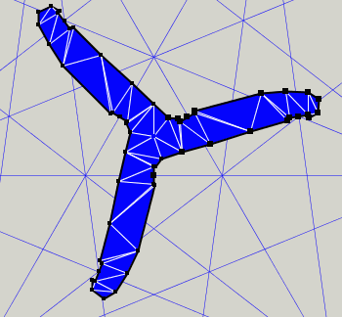 | 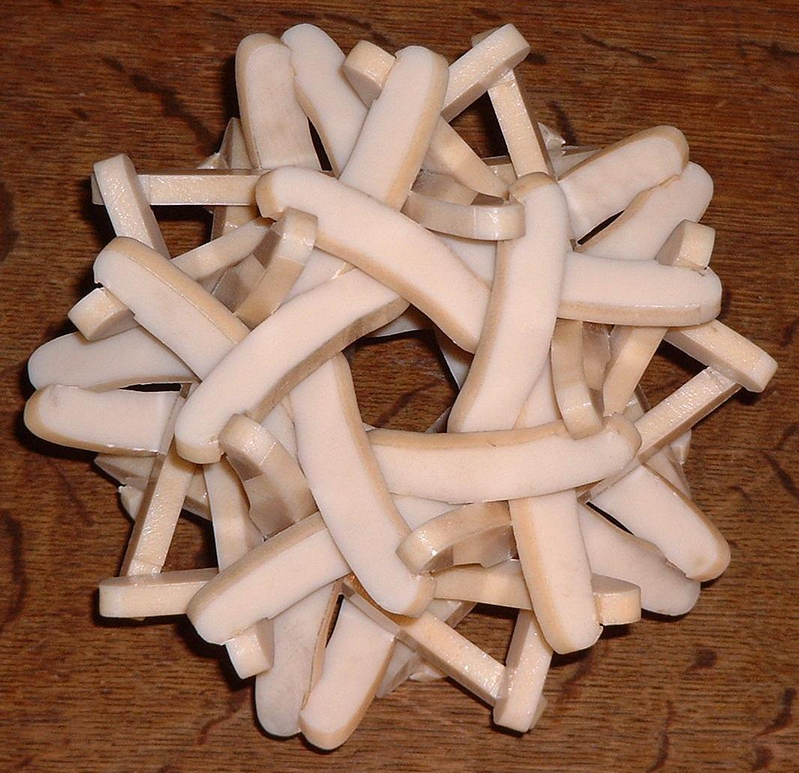
Figure 3a: Part based on icosahedron. | Figure 3b: Assemblage of twenty pieces.

Figure 3 illustrates another puzzle based on the same idea, but with twenty three-armed pieces arranged like an icosahedron. The background of lines in Figure 3a is the stellation diagram of the icosahedron [1]. The parts mate with each other in pairs near the center and at their tips. Both these locations are 2-fold axis points in the stellation diagram. The example in Figure 3b is laser-cut from ABS plastic, about 6 inches in diameter. It can be understood as five subsets of four pieces each, which make five tetrahedral sub-arrangements. So the design can be seen as based on the uniform compound of five tetrahedra. I can assemble it alone, but it is challenging fun to assemble this as a two-or-more person activity.

The 12-piece design in Figure 4 is based on the dodecahedron, but now the mating points are at an inner 3-fold axis where the parts spiral around each other and an outer 2-fold axis where pairs snap together. The pieces for the 3-inch model in Figure 4b are made of nylon, using a selective sintering process in which a computer-controlled laser melts nylon powder to form the parts. Although this solid freeform fabrication process can directly make 3D forms—it could even make the entire model in its assembled state—here it was used to make a stack of 2D parts for me to assemble. Nylon is strong and flexible, so it is very pleasurable to snap them together and discover what a very stable model they make. A ten-inch laser-cut aluminum version of this design is illustrated below in Figure 12.

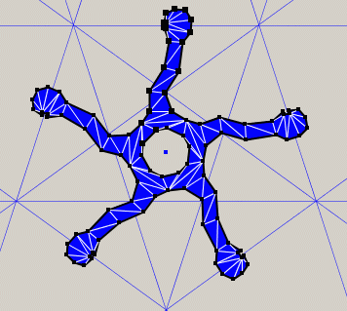 | 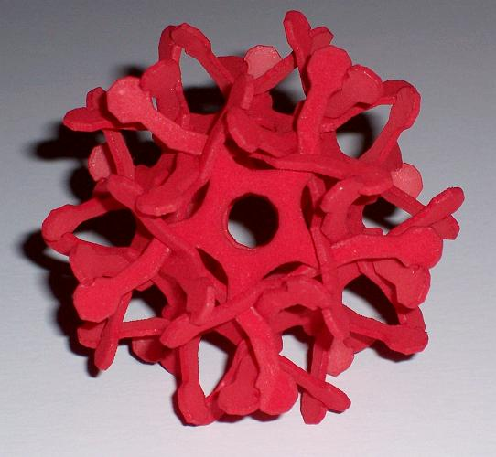
Figure 4a: Part based on dodecahedron. | Figure 4b: Assemblage of twelve pieces.

The design in Figure 5a is based on the stellation diagram of the rhombic triacontahedron. The parts meet in orthogonal groups of three (like the corners of a cube) at “mouths” on the 3-fold axis points. The inner mating points are 2-fold axis points where they meet in pairs. Also made of nylon by selective laser sintering, thirty parts assemble to make the 5-inch model shown in Figure 5b. This puzzle is very tricky to assemble because everything tends to fall apart until everything is all together. But the result is quite stable. To visualize it during assembly, it is helpful to know that the parts’ inner segments (from 2-fold point to 2-fold point) form pentagonal rings that are interlocked in the manner of Holden’s six-pentagon “orderly tangle” [3].

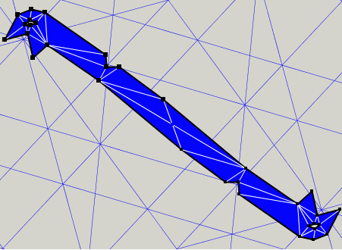 | 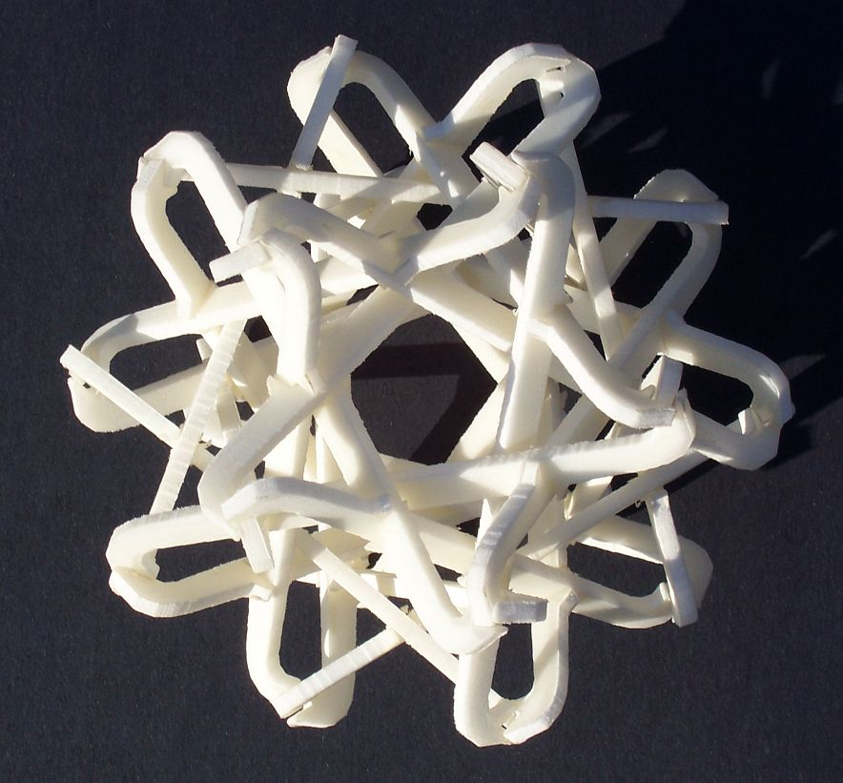
Figure 5a: Part based on rhombic triacontahedron. | Figure 5b: Assemblage of thirty pieces.
From the octahedron comes the eight-piece design shown in Figure 6. The inner connection point is a 2-fold axis point at the midpoint of the octahedron edge. The outer connection point is a 3-fold axis point above the center of a face. The model in figure 6b is made of eight parts cut with scissors from card stock. It is easy to visualize the form during assembly, because the corners point in the directions of a cube’s vertices, but it is amazingly tricky to assemble alone. They tend to fall apart until the final one is positioned. But after assembly, it is amazingly stable. One can throw it high in the air and catch it without any fear of spontaneous deconstruction. Because it has just eight smooth parts, it is the easiest to make by hand of the puzzles in this paper. A template for it is included as an appendix. Copy it to cardstock, carefully cut the parts, and enjoy the frustration! The result is about four inches across from tip to tip.

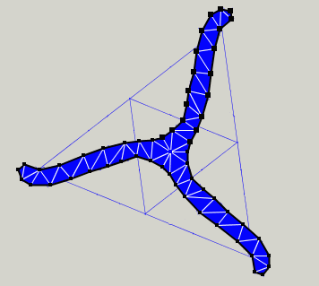 | 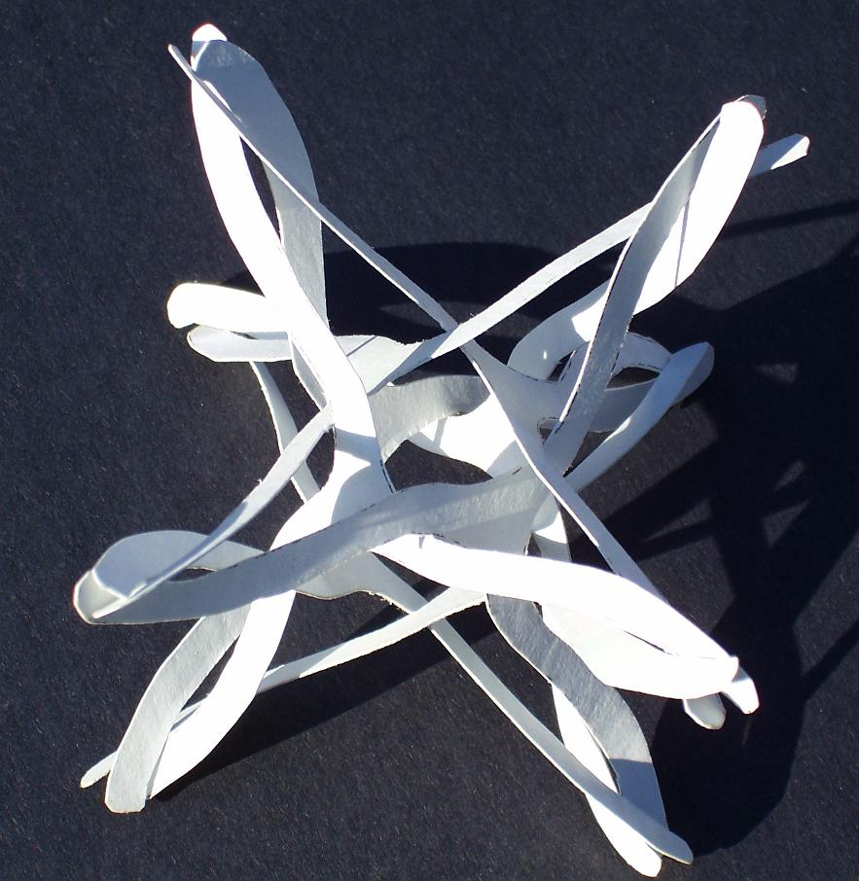
Figure 6a: Part based on regular octahedron. | Figure 6b: Assemblage of eight pieces.

Figure 7 shows another octahedral puzzle. As shown here, this one turned out not to be very stable. The 4-inch card stock model of Figure 7b easily falls apart, so I put little drops of glue on the outer tips to secure it. I expect that extending the tips of the arms will fix the problem.

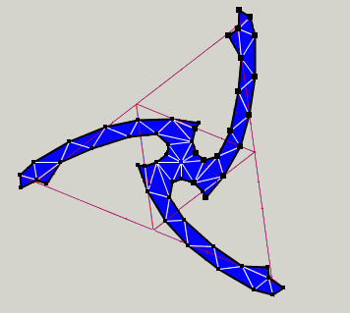 | 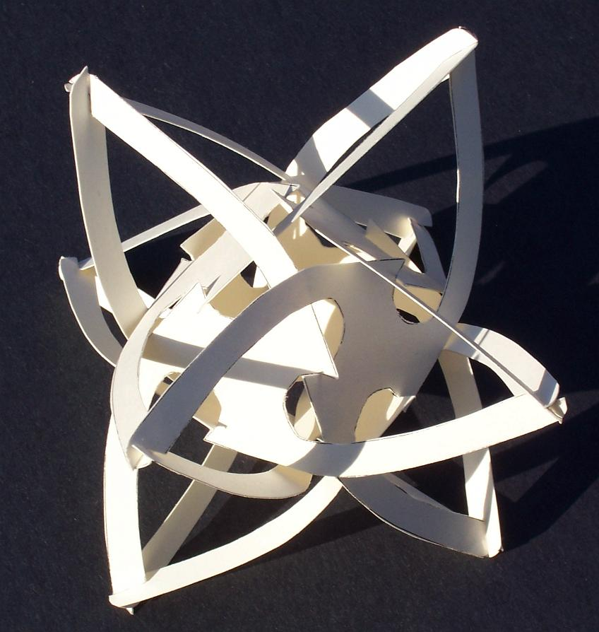
Figure 7a: Part based on regular octahedron. | Figure 7b: Assemblage of eight pieces.

Another thirty-part design based on the rhombic triacontahedron is shown in Figure 8. It is similar to the design of Figure 5 in that the “mouths” are at 3-fold axis points where the parts meet in orthogonal planes. But the inner mating points here are at 5-fold points, which make for a very challenging assembly. Again, this is highly stable when complete, but very unstable until the last few parts are positioned. The 12-inch model in Figure 8b is laser-cut from plastic foam. Fifteen parts of two colors are randomly intermixed, with no pattern to the color arrangement. A visualization aid for assembly is that the parts’ inner segments (from 5-fold point to 5-fold point) form the edges of an icosahedron.

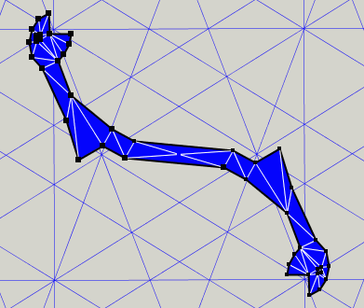 | 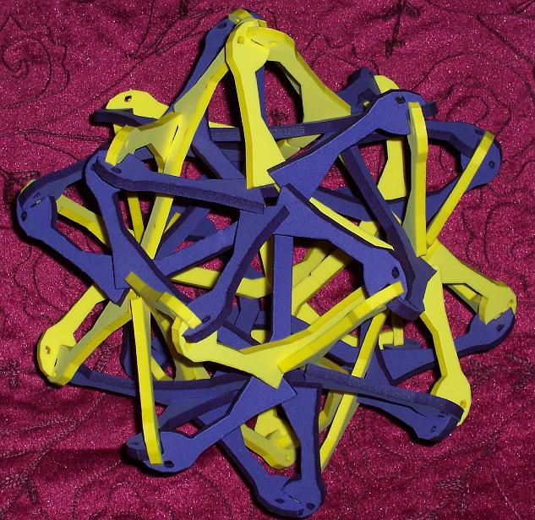
Figure 8a: Part based on rhombic triacontahedron. | Figure 8b: Assemblage of thirty pieces.

Figure 9 illustrates a twenty-part design based on the icosahedron. The components in Figure 9b are made from ABS plastic on a fused deposition modeling machine. Figures 10 and 11 show virtual images of more complex designs I have not yet made. Each has potential pitfalls to be carefully worked out concerning stability, thickness, springiness, or assemblability. I expect to explore more ambitious designs after gaining experience with simpler puzzles. Structures such as Figures 10 and 11 require considerable insight to judge if rigid parts can be maneuvered past each other for assembly.

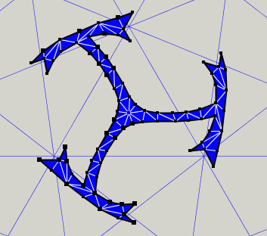 | 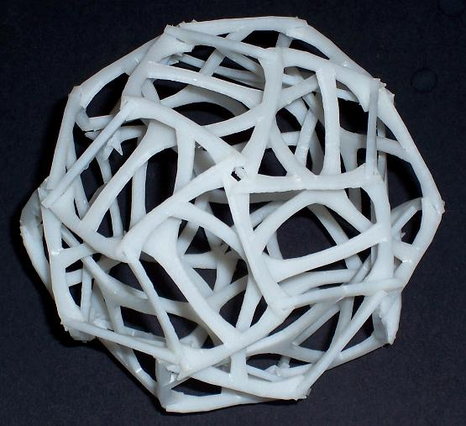
Figure 9a: Part based on icosahedron. | Figure 9b: Assemblage of twenty pieces.
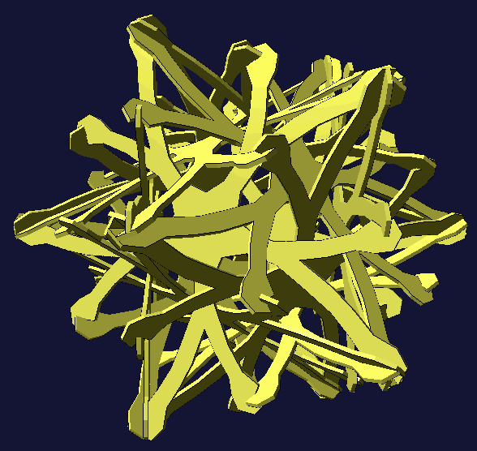 | 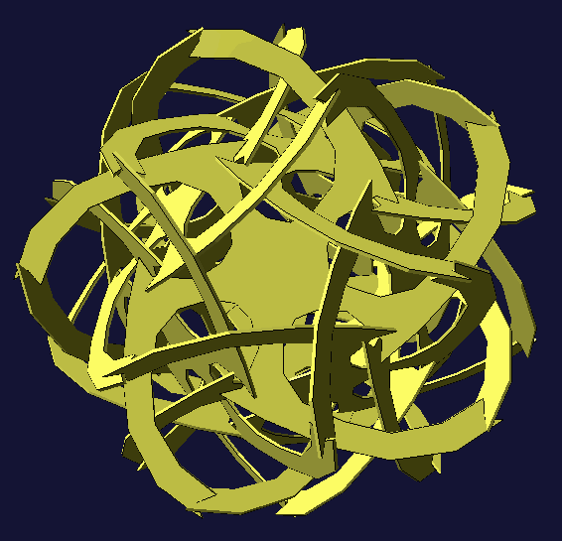
Figure 10: 12-Part design based on dodecahedron. | Figure 11: 12-Part design based on dodecahedron.

3. Conclusions

Puzzle expert Jerry Slocum gives the following definition: A mechanical puzzle is a self-contained object, composed of one or more parts, which involves a problem for one person to solve by manipulation using logic, reasoning, insight, luck, and/or dexterity [6]. The sculpture puzzles presented here are intended to be good puzzles by that definition (and maybe good multi-person puzzles too). They are also intended to be attractive as sculptures when assembled, with a symmetric intricacy that appeals to people with an aesthetic taste for mathematical structure.

In my constructive sculpture, connectors are an important issue that I carefully address [4]. I put much effort into the design of connections between parts, e.g., bevels and glues, or brackets and screws. From the perspective of simplicity, the ultimate solution is to have no connector, so the parts directly mate together. Of course, a consequence of such a design is that by reversing the process the parts can be directly disassembled. This would not be desirable for a public sculpture where vandalism is a concern. But for a puzzle sculpture, it can be an elegant design. Many puzzles and sculptures are of a snap-together nature. Works of Rinus Roelofs stand out as particularly clever in this regard [5].

While expensive to produce in the prototyping stages illustrated here, such as Figure 12, I hope to develop some designs to the point where they can be produced inexpensively. Because they are made of flat parts, they should be stampable in plastic or metal. But thickness, stiffness, burrs, surface finish, etc, are all to be addressed.

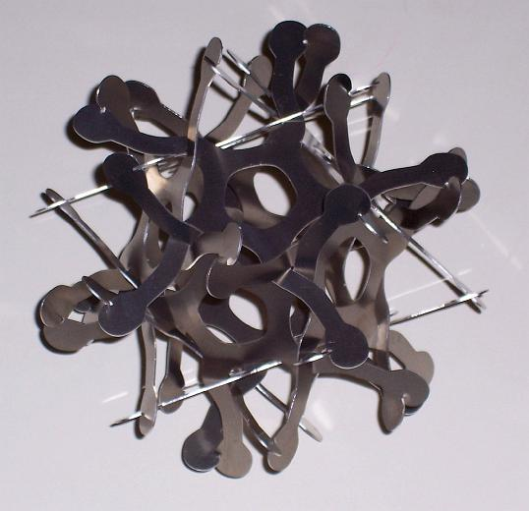
Figure 12. Laser-cut aluminum version of Figure 4.

References

[1] H.S.M. Coxeter, et al., The Fifty-Nine Icosahedra, U. Toronto Pr., 1938.
[2] G.W. Hart, "Sculpture from Symmetrically Arranged Planar Components", in Meeting Alhambra, (Proceedings of ISAMA-Bridges 2003, Granada, Spain), Javier Barrallo et al editors, Univ. of Granada, 2003, pp. 315-322.
[3] G.W. Hart, "Orderly Tangles Revisited", in Renaissance Banff, (Proceedings of Bridges 2005: Mathematical Connections in Art, Music, and Science, Banff, AB), Reza Sarhangi and Robert Moody editors, 2005, pp. 449-465.
[4] G.W. Hart, http://www.georgehart.com
[5] Rinus Roelofs, “Three Dimensional and Dynamic Constructions Based on Leonardo Grids”, in Renaissance Banff, (Proceedings of Bridges 2005, Banff, Alberta), Reza Sarhangi and Robert Moody editors, 2005, pp. 161-168.
[6] Jerry Slocum, et al., Puzzles Old and New, Univ. Wash. Pr., 1986, p. 4.

Acknowledgments: For fabrication assistance with the models illustrated here, I thank Erik Demaine and Martin Demaine (Figure 2c), George Miller of www.puzzlepalace.com (Figures 2d and 8b), Chris Palmer (Figure 2b), Jim Quinn (Figures 4b and 5b), and Abhi Shelat (Figure 3b).

Note: The sculpture puzzle designs in this paper are copyright 2006 by George W. Hart. They are presented for academic use and not for commercial reproduction without expressed written permission.

Appendix: Template for Figure 6. Copy to card stock, enlarged so rectangle is 8.5 by 11 inches.
